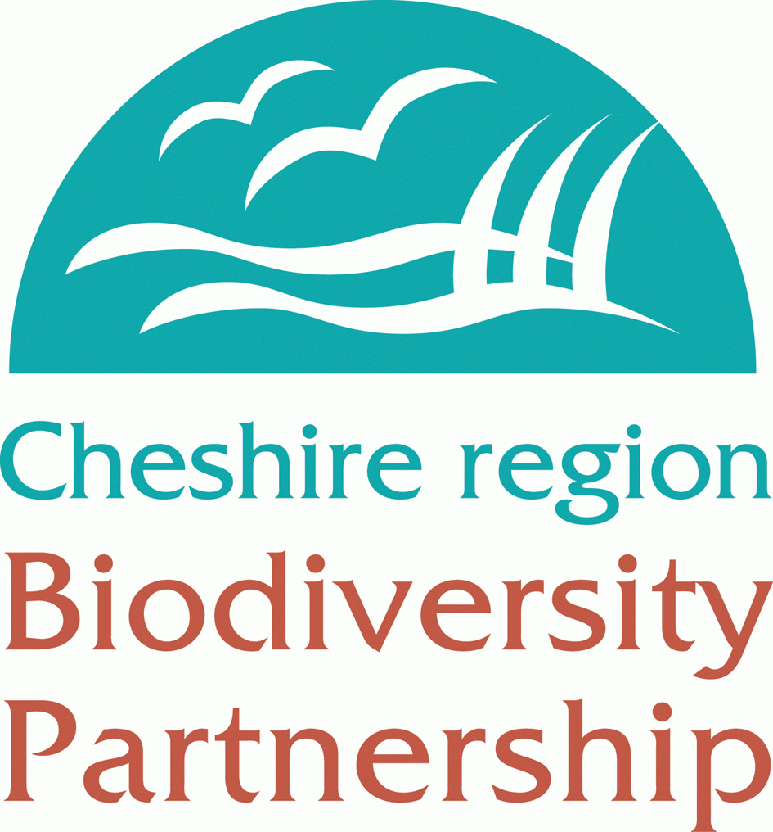


Cheshire region Biodiversity Partnership

Small Projects Grant Scheme

2006/07

Cheshire region Biodiversity Partnership (CrBP)
The CrBP consists of over forty government, charitable and voluntary organisations committed to delivering the Cheshire region Biodiversity Action Plan (CrBAP), Countdown. Countdown includes seventy-three action plans for species and habitats that are considered vulnerable or declining in Cheshire and, in many cases, the UK. Each action plan contains targets that work towards the common vision of ‘A Cheshire richer in wildlife by 2020’. Projects that contribute to this vision through achievement of local and/or UK BAP targets are eligible to apply for this funding. The CrBAP can be viewed at www.cheshire-biodiversity.org.uk and the UKBAP www.ukbap.org.uk.
The Grant Scheme
Grants up to £1000 are available for biodiversity projects in the Cheshire region.
To qualify for the grant, your project should aim to contribute to:
- Delivery of objectives and targets for any of the species or habitats included in the Cheshire region Biodiversity Action Plan
And/or
- Delivery of objectives or targets for any of the species or habitats included in the UK Biodiversity Action Plan
Notes For Applicants
  - We hope to renew and widen this funding for 2007/08 but for this, as the first round, projects must be within new Cheshire i.e. within the local authority areas of Cheshire County Council, Vale Royal, Macclesfield, Congleton, Crewe & Nantwich, Chester City, Ellesmere Port and Neston.
  - The grant can pay for costs of the project such as materials, research and surveys, habitat management, technical advice, on-site interpretation and training. It should not pay for core funding for a group and there will be restrictions on income earning projects.
  - The funding must be used for new biodiversity conservation work and not to fulfil any existing agreements such as SLAs, agri-environment works, planning obligations. It can not be used to match other CCC funding.
  - Any non – profit group or organisation may apply. If you are applying on behalf of a non-constituted group and therefore do not have a bank account (such as a Biodiversity Action Group) you may nominate an organisation to administer the project finances. Eligible organisations include Local Authorities, Registered Charities, Government Organisations.
  - A nominated person must sign the application form accepting the conditions of grant on behalf of those involved in the project
  - The applicant must supply adequate information to justify the project
  - Applications must be received by Monday 16th October 2006. The Cheshire region Biodiversity Partnership Steering Group will then consider all applications; successful applicants will be informed as soon as possible after applications have been assessed and no later than 3rd November 2006. Unsuccessful applicants will receive feedback as to why their application was not successful. Applicants should not start work on projects until after receipt of an offer letter
  - All works must be completed, claimed for and inspected by 15th March 2007.
  - Grants will be paid retrospectively based on an accepted specific offer, satisfactory completion of the scheme and production of receipted invoices that clearly relate to those works outlined in the application.
  - Any publicity for the project, including signage on site, must acknowledge the support of the Cheshire region Biodiversity Partnership and Cheshire County Council.
  - The maximum amount of grant from this scheme will be £1000. However, this funding can be used as match against a bigger project.
  - Although it is not a requirement of the grant scheme for applicants to secure match-funding, applicants are encouraged to do so. Match funding can include voluntary labour or ‘in kind’ funding calculated as follows:
Type of voluntary help | Per hour | Per day
General unskilled labour (e.g. scrub clearance, planting, ditch digging, basic admin support)  Specialist, skilled labour (operating specialist machinery, driving, using chemicals)  Specialist services (supervising others, training, surveying, photography, printing, designing)  Professional services (consultants, lawyers, architects, engineers, accountants etc) | £6.25  £18.75  £31.25  £50.00 | £50.00  £150.00  £250.00  £350.00
Voluntary labour contribution can be determined by the following:

  - Grants are not mandatory. They will be offered at the discretion of the Cheshire region Biodiversity Partnership Steering Group
  - A report on the projects that receive grant funding will be produced at the end of this grant scheme.
  - Applicants will be required to produce a short summary of their project for CrBP publicity purposes and BARS reporting.
  - Applicants within the Vale Royal area are encouraged to apply for a Vale Royal Nature Conservation grant from Vale Royal Borough Council as match funding. Application forms can be obtained either from Elaine Weller, Nature Conservation Officer, Vale Royal Borough Council (Tel: 01606 867748) or downloaded from www.cheshire-biodiversity.org.uk
If you require any assistance or would like to have an informal chat about your project before completing the application please contact Charlotte Harris, Cheshire region Biodiversity Action Plan Coordinator.
charris@cheshirewt.cix.co.uk
Tel: 01270 610180

Application Form
Applications must be received by Monday 16th October 2006. You will be notified of the outcome as soon as possible after the assessors have considered your application and no later than 3rd November 2006.
Please complete this form as fully as possible, using additional sheets and including supporting information as much as necessary
1. Contact details
Name of group/organisation (if applicable):

Name of main contact:
Address:

Postcode: | Tel:
email:

2. Project details

Project name (if applicable):

Project outline (continue on separate sheet if necessary):

Location of project:

Map grid ref of project:

Who is the landowner?

If you do not own the land, has the landowner given their consent? Yes/No
If Yes, please attach evidence (eg a letter of support).
3. Project aims

Project aim | Cr/UKBAP target/objective to be delivered | Contribution your project will make to BAP target
Please list your main project aims and state which Cr/UK BAP targets they will help deliver. When detailing the contribution your project will make to BAP targets please try to be specific about quantitative outcomes (e.g. acres/hectares of habitat restored or created)

4. Project assessment, evaluation and recording

How will you assess progress towards your project aims and how will you evaluate and record the success of your project? Please state assessment method and how any data collected will be made available or disseminated

5. Sustainability of outcomes

How will the outcomes of the project be sustained after our funding ends?

Details of costs (costs should be exclusive of VAT) | Cost
Total cost
Grant requested
6. Project budget

6b. Matched funding

Please give details of all other sources of funding for this project (including volunteer time or ‘in kind’ funding)

Source | Cash or in kind | Amount

7. Declaration

Signed: | Date:
Print name:
I have read and accept the ‘Notes for Applicants’. To the best of my knowledge the information supplied with this application is correct

Please list any enclosures sent with this application:

8. Financial details

Please tell us who the grant cheque should be made payable to:

If your group/organisation does not have a bank account you may nominate an appropriate organisation to manage your project finances. Please state the name of this organisation in the box above.

Please return this form to:

Charlotte Harris
C/o Cheshire Wildlife Trust
Grebe House
Reaseheath
Nantwich
Cheshire
CW5 6DG

